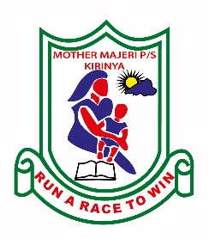**MOTHER MAJERI NURSERY SCHOOL**

**END OF TERM II EXAMINATION, 2024**

**CLASS : BABY CASS**

**SUBJECT: ENGLISH**

**My name is ________________________________stream_____**

**1. Copy the same letters.**

|  |  |  |  |  |
| --- | --- | --- | --- | --- |
| a | b | c | f | h |
|  |  |  |  |  |

**2. Match the same**

b h

c a

f e

e f

a c

h b

3. **Circle the same.**

4. **Read and copy.**

|  |  |  |  |
| --- | --- | --- | --- |
| 31,400+ Egg Clipart Stock Illustrations, Royalty-Free Vector ... | 12,022 Mat Outline Images, Stock Photos, and Vectors ... | Sun Line Drawing Royalty-Free Images, Stock Photos ... |  |
| egg | mat | sun | box |
|  |  |  |  |
|  |  |  |  |

5. **Read and match.**

box sun

tin pot

fan tin

pot box

sun fan

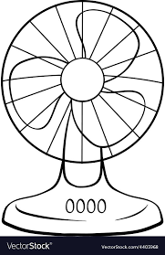6. **Match letter to picture.**

s

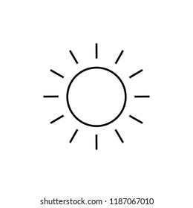

p

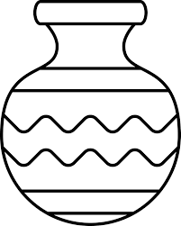

f

**END**